Episode 4: 1978: Mike
History: teaching strategies
Unit focus: Australian History
Year level: Years 3–6
The Australian curriculum: History
The national history curriculum will be based on the interrelationship between historical knowledge, understanding and skills.
The history curriculum across Years 3–6 will be developed around four focus questions:
- What do we know about the past?
- How did Australians live in the past?
- How did people live in other places?
- How has the past influenced the present?
Historical knowledge and understanding
- Historical significance: The principles behind the selection of what should be remembered, investigated, taught and learned ...
- Evidence: How to find, select and interpret historical evidence ...
- Continuity and change: Dealing with the complexity of the past. This involves the capacity to understand the sequence of events, to make connections by means of organising concepts ...
- Cause and consequence: ... the ways that the legacy of the past shapes intentions and the unintended consequences that arise from purposeful action ...
- Historical perspectives: The cognitive act of understanding the different social, cultural and intellectual contexts that shaped people's lives and actions in the past ...
- Historical empathy and moral judgement: The capacity to enter into the world of the past with an informed imagination and ethical responsibility ...
- Contestation and contestability: Dealing with alternative accounts of the past. History is a form of knowledge that shapes popular sentiment and frequently enters into public debate ...
- Problem solving: Applying historical understanding to the investigation, analysis and resolution of problems ...
Students will develop historical skills, which include:
- using common historical terms for describing time and sequencing events and developments in chronological order
- asking questions, finding relevant answers, and constructing informed responses
- developing a basic understanding of how evidence can be used to provide historical explanations
- developing appropriate techniques of organisation and communication.
Reproduced with permission of the Australian Curriculum, Assessment and Reporting Authority (ACARA) from Shape of the Australian Curriculum: History, 2009, pp. 6, 8, http://www.acara.edu.au/news_media/publications.html . Further information, including any updates, is available at http://www.acara.edu.au/
Episode clip: Performance cars
Activity 1: Muscle cars
Subthemes: Inventions and electronic media; Transport
'XB', '351-GT', '250ci', 'six-cylinder' ... what do these things mean? To a car enthusiast, it all makes sense. The 'muscle cars' of the 1960s and 1970s were flamboyant racing machines, attracting a large community of enthusiasts.
Discover
- Ask students to research iconic cars from the 1970s. Make a list of these cars and create a database. The database can be presented as a poster or as an electronic version that all students have access to. Use the following websites as a guide. Encourage students to complete additional research:
- Motore, http://www.motore.com.au
- Falcon GT Club of Australia, http://www.falcongtclub.org
- Old Holden.Com, http://holdenpaedia.oldholden.com
Reflect
- Ask students to create a web page for a car sales company that sells Australian muscle cars from the 1970s. The web page can be set up as a classifieds page similar to those in an online newspaper or trading site. The layout must include the following components:
- a company logo designed by students
- background information on iconic cars from the '60s and '70s (all cars must be Australian)
- a list of five cars for sale in the classifieds section, including their descriptions and prices
- images, diagrams and information on the history of each car.
- Ask students to complete the activity electronically or on paper, and then to participate in a sharing and viewing session.
Download
- Student Activity Sheet H4.1: Selling your muscle car online
Activity 2: Environmental impact
Subthemes: Inventions and electronic media; Transport
Cars have had a dramatic impact on our natural environment. Air quality is compromised, greenhouse gases are emitted, and there is evidence of the overuse of natural resources and noise pollution. Muscle cars are regarded as not being environmentally friendly.
Discover
- Ask students to compare and contrast cars of the 1970s with the cars of today. They can use the table in Student Activity Sheet H4.2 or create a table of their own. Have students compare the following features in the table:
- structure
- materials
- components.
- Discuss the materials used to make cars in the past and today. What are the various engine capacities of the cars and what amount of natural resources are used? Focus the discussion on the effects these cars have on the environment.
Reflect
- Ask students to design and create the perfect muscle car. The design should take into consideration the environmental needs and responsibilities of today. The modern muscle car can be presented electronically or as a poster. Kahootz 3 is an ideal 3-D animation software program to use. The software is available for purchase from the Australian Children's Television Foundation (ACTF) website at http://www.kahootz.com
- Ask students to create their modern muscle car in 3-D using materials available in the classroom.
Download
- Student Activity Sheet H4.2: The 'green' machine
Activity 3: Men and machines
Subthemes: Inventions and electronic media; Transport
This clip shows how some men and boys are obsessed by cars, particularly performance cars. The passion for cars presents a language of its own.
Discover
- List the cars that are referred to in this clip. View the script of Episode 4: 1978: Mike to identify the cars. Included in the references should be:
- Holden Kingswood HQ
- Holden Monaro GTS
- Ford Cobra
- 1971 Ford XY GT-HO
- LJ Torana GTR XU-1
Reflect
- Assign a car to each group and ask students to research their car and find images of it. Organise a Grand Prix quiz where the students identify 10 key facts. Share this information in class. The questions and answers should be written on cards.
- The cards from all groups are then pooled in a question bank. Ask the students random questions from the bank. Anyone can answer the questions. Points should be given for correct answers and deducted for wrong answers. The group with the most points are the Grand Prix winners and are awarded a prize.
Download
- Student Activity Sheet H4.3: Name that car
Episode clip: The card collection
Activity 4: Migrant rights
Subthemes: Gender roles; Multiculturalism
The 1970s saw a groundswell of political activism in Australia on many fronts: the peace movement, environmental protection, feminism and workers' rights. The Galbally Review of Post-Arrival Programs and Services for Migrants opened the door to the idea of migrants' rights, a concept that paved the way for multiculturalism.

To learn about the struggle of migrant women during this era, go to eMelbourne: the city past and present, 'Migrant women and feminism', http://www.emelbourne.net.au/biogs/EM02141b.htm
Discover
- In this clip, the role of the women in Mike's family is clearly defined. Ask students to analyse the women in Mike's family, their roles and the differences in their roles.
Reflect
- Ask students to complete the 'historyface' template for the women in Mike's family: his grandmother (Yaya), mother (Janice) and aunt (Sofia). The students can share their findings with the rest of the class.
Download
- Student Activity Sheet H4.4: Mike's family profiles
Activity 5: Changes
Subthemes: Gender roles; Multiculturalism
Fashions of the 1970s extended the look established in the 1960s with the mini-skirt. Fashions for women became more daring and colourful, as 'mod', 'surfie', 'hippy' and 'disco' styles became fashionable. Fashions for men became more casual, pairing jeans with sandals, and flairs with platform shoes.
Discover
- Discuss the topic, 'How does fashion highlight the changing tastes in culture, attitudes and behaviour of each era?' and make a list of how fashion creates a 'point of view' in history.

- Use the following websites as stimulus:
- Macgregor State School, http://www.macgregoss.eq.edu.au/aussie.htm
- Vintage Now, http://www.vintage-now-clothing.com
- Rusty Zipper, http://www.rustyzipper.com
- Google Images, http://images.google.com.au
- Ask students to talk with their parents about fashion in the 1970s. They could bring some photos or original outfits belonging to their parents and share these with the class.
Reflect
- Ask students to use the body template in Student Activity Sheet H4.5 to create three different 1970s outfits using paper and fabric. A photo of the student's face can be added to the template to personalise it. Upload the images to the school website as an album of 1970s fashion.
Download
- Student Activity Sheet H4.5: Fashion of the 1970s
Activity 6: Wheaty Flakes cards
Subthemes: Customs and traditions; Entertainment and games
Card collecting and trading has been a favourite pastime of many Australian children for decades. Collecting cards that are rare is the key to a good collection.
Discover
- Ask students to discuss the following questions and create a mind map of ideas:
- What types of cards are collected and traded?
- Are card collections valuable? If so, which are the most valuable collections?
- Where did card collecting originate and when?
- What changes have impacted on card collecting and trading in the past 50 years?
Reflect
- Ask students to discuss their card collections. Have them write a report on why they collect these type of cards, how they purchase or trade them, what type of cards they need to complete the collection, and which cards are most valuable to them and why.
- Ask students to design their own card that would fit into the collection. The card must have an image and text. It must have a registration number that fits with the number order of the collection.
- Alternatively, ask students to create a series of five cards depicting something of interest to them. The cards should include a picture of the item on the front and information on the back. Students could give a short presentation on why their cards are the most exclusive and sought after by other collectors.
Download
- Student Activity Sheet H4.6: Card collecting
Episode clip: The 'Tippy'
Activity 7: Post-traumatic stress
Subtheme: Australians at war
In Episode 4: 1978: Mike, the 'Tippy' and Mike's father are Vietnam veterans. Michaelis explains to Mike that the Tippy keeps to himself because of his experiences in the war. Many Vietnam veterans endured emotional, physical or psychological trauma during and after the war.
Discuss
- Ask students to explore the reasons why Australia became involved in the Vietnam War. As a class, create a poster fact sheet divided into two columns. The first column, titled 'Pre-war', will list the reasons why Australia became involved. The second column, titled 'Post-war', is for reasons why Australia withdrew troops from Vietnam.
- Create a timeline highlighting Australia's involvement in the war and the main events, dates and people involved.
- Ask students to find out from family members what they thought of Australia's involvement in the war and how they related to the returned soldiers. Students could interview these family members and record their memories as a social history with images or film clips.
Reflect
- Ask students to write an article for the local newspaper based on an interview with a Vietnam veteran, a protest organiser or an ALP politician elected when Whitlam was prime minister. The interview should outline the interviewee's thoughts and actions regarding the Vietnam War and the need to support veterans afterwards.
Download
- Student Activity Sheet H4.7: The Vietnam War
Activity 8: The RSL
Subtheme: Australians at war
Discover
- Invite students to listen to a guest speaker from the Returned and Services League (RSL). The RSL is a valuable community resource that supports returned service people. Contact the local RSL to find out if there are members willing to speak to the class about their experiences.
- Alternatively, students may have a family member who would be willing to come to the classroom to speak.
- The following websites may be useful:
- Returned Services League, http://www.rsl.org.au
- Anzac Day, 'Vietnam', http://www.anzacday.org.au/history/vietnam/overview.html
- Ask students to view the film clip from Screen Australia Digital Learning, 'Australian soldiers on patrol in Vietnam', http://dl.screenaustralia.gov.au/module/322
Reflect
- Ask students to create a Y chart to describe the experiences of the soldiers who were fighting in Vietnam. Ask students to imagine the role of the soldier and write their responses in the Y chart using the three points below.
- What does it look like?
- What does it feel like?
- What does it sound like?
- Have students share their responses with the class.
Download
- Student Activity Sheet H4.8: Y chart: soldiers at war in Vietnam
Activity 9: Old and new
Subtheme: Australians at war
Discover
- Ask students to source a map of Vietnam and enlarge it twice so the detail of the country is evident on both maps. On the map, they should mark the key cities in Vietnam and the division of the country into North Vietnam and South Vietnam at the time of the war. Have students research the battles that Australians were involved in and pinpoint these places on the map. From their research they should write a short paragraph about each battle and add this to the map.
- Ask students to find out which Australian soldiers were decorated for bravery during the Vietnam War, find images of them and write a paragraph on their exploits. Add this information to the map. Build information about Australia's participation by adding it to the map or a timeline.
Reflect
- On the second map, ask students to present information about Vietnam today. Emphasise that the information should reflect modern Vietnam, its industries, exports, government, education policies, culture and so forth. Ask students to find images that are associated with growth and prosperity, people and culture, cities and rural communities. They should also find out about Australia's relations with Vietnam today through business, education and aid. Ask them to reflect on the legacy of the Vietnam War.
Aligned resources
Anzac Day, 'Vietnam', http://www.anzacday.org.au/history/vietnam/overview.html
eMelbourne: the city past and present, 'Migrant women and feminism', http://www.emelbourne.net.au/biogs/EM02141b.htm
Falcon GT Club of Australia, http://www.falcongtclub.org
Fordspec, http://www.fordspec.com.au
Google Images, http://images.google.com.au
Macgregor State School, 'Children's work, Being Australian', http://www.macgregoss.eq.edu.au/aussie.htm
Motore, http://www.motore.com.au
Muscle Car Garage, http://www.musclecargarage.com
Museum Victoria, 'Journeys to Australia, 1940s–60s: a journey for many' http://museumvictoria.com.au/journeys/1940_60s.asp
——'Origins', http://museumvictoria.com.au/origins
Old Holden.Com, http://holdenpaedia.oldholden.com
Returned Services League, http://www.rsl.org.au
Rusty Zipper, http://www.rustyzipper.com
Screen Australia Digital Learning, 'Australian soldiers on patrol in Vietnam', http://dl.screenaustralia.gov.au/module/322
Vintage Now, http://www.vintage-now-clothing.co
Student Activity Sheet H4.1 |  | Episode 4: 1978: Mike
Activity 1: Muscle cars |  | Clip: Performance cars
Selling your muscle car online
Create a web page for a car company that sells Australian muscle cars from the 1970s. The webpage can be set up as a classifieds page similar to those in an online newspaper or trading site.
- The layout must include the following elements:
- a company logo designed by you
- background information on iconic Australian cars from the era ('60s and '70s)
- a list of five cars for sale in the classifieds section, including their descriptions and the sale prices
- images, diagrams and information on the history of each car.
- Draft your ideas here:

Student Activity Sheet H4.2 |  | Episode 4: 1978: Mike
Activity 2: Environmental impact |  | Clip: Performance cars
The 'green' machine
- Compare and contrast two cars of the 1970s with two cars of today. Create a comparative table with the following features:
Car list | Structure | Materials | Components
1970s cars
1
2
Today's cars
1
2
- Design the perfect muscle car. The design should take into consideration the environmental needs and responsibilities of today. The modern muscle car can be created using a computer or as a poster. Plan, draw, design and outline the car's environmentally friendly attributes.
- Research car production methods that reduce impact on the environment. Some examples might be recycled, double-glazed glass windows or recycled rubber on tyres.
- Ensure that your facts are correct and make a note of the websites you use for this activity.

Student Activity Sheet H4.3 |  | Episode 4: 1978: Mike
Activity 3: Men and machines |  | Clip: Performance cars
Name that car
- List eight cars from the clip and find an image of each. View the script of Episode 4: 1978: Mike, to help identify the cars.
Name of car | Image or description of car
1 Holden Kingswood HQ
2
3
4
5
6
7
8
- Select one of the cars listed above and find 10 key facts about it. Write each of the 10 facts on separate cards. Pool the facts with the rest of the class in a question bank and participate in the Grand Prix quiz to win a prize.
Name of car
1
2
3
4
5
6
7
8
9
10

Student Activity Sheet H4.4 |  | Episode 4: 1978: Mike
Activity 4: Migrant rights |  | Clip: The card collection
Mike's family profiles
Complete this 'historyface' for the women in Mike's family: his grandmother (Yaya), mother (Janice) and aunt (Sofia).
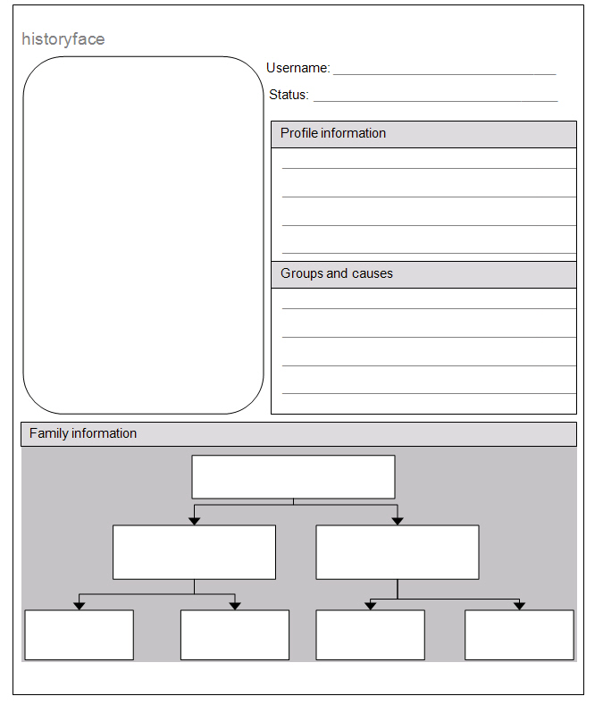

Student Activity Sheet H4.5 |  | Episode 4: 1978: Mike
Activity 5: Changes |  | Clip: The card collection
Fashion of the 1970s
Use the template below to create three different outfits inspired by the 1970s. Use paper and fabric to create your items of clothing. Make sure you add tabs to the clothes so you can attach them to the template. The result will be a paper doll with three different outfits.
The outfits must be made to fit the size of the template. You can paste a photo of your face and add it to the template.
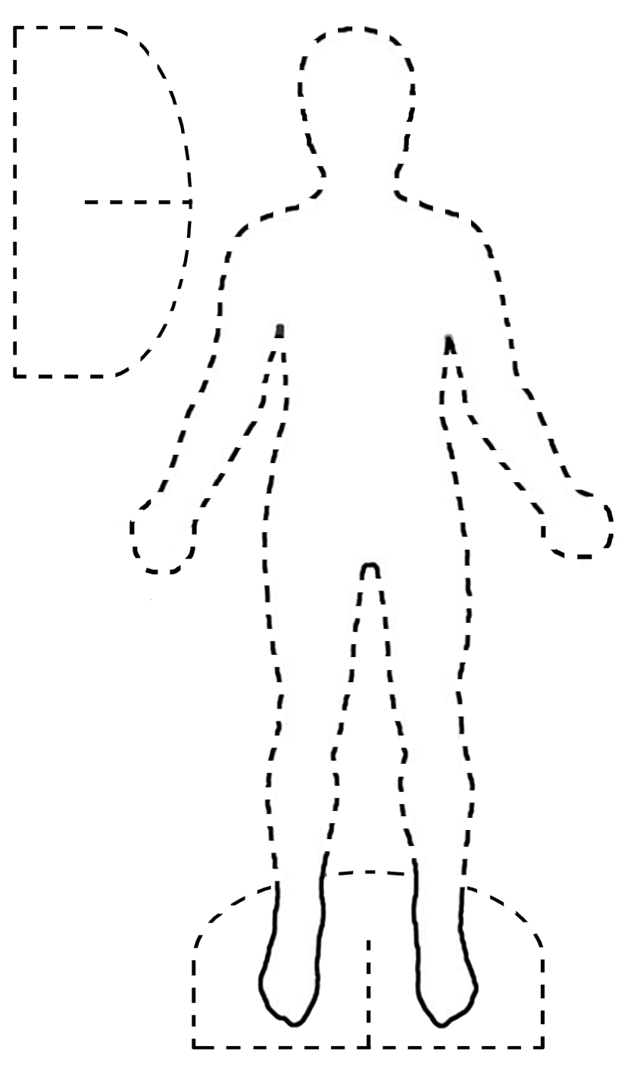

Student Activity Sheet H4.6 |  | Episode 4: 1978: Mike
Activity 6: Wheaty Flakes cards |  | Clip: The card collection
Card collecting
Card collecting and trading has been a favourite pastime of many Australian children for decades. Collecting cards that are rare is the key to a good collection.
- Respond to these questions and, with the class, create a mind map of ideas.
- What types of cards are collected and traded?

- Are card collections valuable? If so, which are the most valuable collections?

- Where did card collecting originate and when?

- What changes have affected card collecting and trading in the last 50 years?

- Discuss card collecting with the class and write a report about your own or another student's collection. In your report, answer the questions:
- Why do you collect these types of cards?
- How do you purchase or trade them?
- What types of cards are needed to complete the collection?
- Which cards are the most valuable and why?
- Choose one of the following activities:
- Design your own card that would fit into a collection. The card must have an image and text. It must have a registration number that fits with the number order of the collection.
- Create a series of five cards that reflects one of your interests. There should be a picture on the front of each and some information on the back. Give a short presentation on why your cards are the most exclusive and sought after by other collectors.

Student Activity Sheet H4.7 |  | Episode 4: 1978: Mike
Activity 7: Post-traumatic stress |  | Clip: The 'Tippy'
The Vietnam War
- Create a poster fact sheet divided into two columns. In the 'Pre-war' column, list the reasons why Australia became involved in the Vietnam War. In the 'Post-war' column, list the reasons why Australia withdrew troops from Vietnam.
Pre-war: reasons to be involved | Post-war: reasons to withdraw
- Write an article for the local newspaper based on an interview with a Vietnam veteran, a protest organiser or an Australian Labor Party politician elected when Whitlam was prime minister. The article should outline the interviewee's thoughts and actions regarding the Vietnam War and its veterans.
You may present your information in the following ways:
- a blog
- a slideshow presentation with sound and images
- a journal entry
- an oral presentation using your recorded voice.

Student Activity Sheet H4.8 |  | Episode 4: 1978: Mike
Activity 8: The RSL |  | Clip: The 'Tippy'
Y chart: soldiers at war in Vietnam

What does it look like?

What does it feel like?

What does it sound like?

Episode 4: 1978: Mike
English: teaching strategies
Unit focus: English
Year level: Years 3–6
The Australian curriculum: English
The national English curriculum is based on three interrelated strands:
Language: Knowing about the English language ...
Literature: Understanding, appreciating, responding to, analysing and creating literature ...
Literacy: Growing a repertoire of English usage …
Reproduced with permission of the Australian Curriculum, Assessment and Reporting Authority (ACARA) from Shape of the Australian Curriculum: English, 2009, p. 6, http://www.acara.edu.au/news_media/publications.html. Further information, including any updates, is available at http://www.acara.edu.au
Episode clip: Performance cars
Activity 1: Cars
Subthemes: Language and scripting; Transport
The muscle cars of the 1960s and 1970s were flamboyant racing machines that attracted a large number of enthusiasts.
Discover
- In Episode 4, the young character Mike is very interested in cars 'with muscle'.
- Ask students to define what cars could be classed as muscle cars. Ask them to listen to the cars named in the first clip and compile a class list .For example MG; Kingswood; and 1971 Ford XB 351-GT may be included in the list. What does it all mean? To a car enthusiast, it all makes sense.
- As a class, discuss the information given in the clip as well as what students understand from the dialogue about the cars. Ask students to write their own definition of muscle cars and share this with the class.
Reflect
- Ask students to investigate the one of the muscle cars of the 1960s and 1970s, then write a persuasive editorial piece (with words and images) that includes the following elements:
- Why would they like to own this car?
- What are the main features of the car?
- What makes this car special?
- Students can present their editorial electronically using a publishing program, or on a small poster to share with the class.
Download
- Student Activity Sheet E4.1: Cars with muscle
Activity 2: 'Rev head'
Subthemes: Language and scripting; Transport
- There is specific vocabulary and many terms associated with muscle cars. Some of these are mentioned throughout the clip and the episode. These terms include carburettor; air filter; 'GT stripe'; 'She's ready to go!' and 'non-rev head'.
Discover
- Brainstorm a class list of car-related terms. Ask each student to select ten words of interest, to find out their meaning and, if relevant, locate an image of the car part or car.
Reflect
- Ask students to create a mini-dictionary of muscle car terms from the list. The mini-dictionary must include pictures and meanings relating to the term, or word. If possible develop this information into a website, and upload it to the school server.
- Start a blog to communicate with other students who may also be interested in muscle cars.
Download
- Student Activity Sheet E4.2: Mini-dictionary of muscle car terms
Episode clip: The card collection
Activity 3: Card collecting
Subthemes: Customs and traditions; Entertainment and games
Discover
- Mike has a card collection that is important to him. As a class, discuss the reasons why Mike might be interested in collecting cards. Ask the students to consider:
- What does this tell the audience about the character of Mike?
- What could be the reasons the filmmaker included this information in the story?
Reflect
- Conduct a class survey of the things students collect and present these findings as a pictorial representation such as a bar graph, or with text and images. Evaluate and assess the most popular collections and describe the reasons given by students for collecting these items.
- As an extension activity, students can survey members of their family (parents, grandparents and siblings to find out what they collected when they were young). Encourage students to collate this information on a graph, electronic spreadsheet, or record it manually on paper.
- The survey results can be presented to the class, showing the differences and similarities in collections over the years. As a class, discuss the variety of objects collected over different generations and highlight the differences in objects collected today compared to in the past.
- Encourage students to bring example collections to the classroom to share and compare.
Download
- Student Activity Sheet E4.3: Card collecting
Activity 4: Music and fashion
Subthemes: Art, music and literature; Fashion; Relationships
Discover
- Music is used by the filmmaker to introduce Mike's young aunt Sofia as she plays records in her bedroom with her friend. As a class, discuss why the filmmaker chose to use music to introduce this scene and focus on Sofia when she held a record in her hand as music was played. Was this to indicate her interest in music?
Reflect
- Ask students to create a character profile of Sofia that answers the following questions:
- How is Sofia dressed?
- What type of fashion are her clothes representative of for the era?
- What could have influenced her style?
- What style of music is she listening to?
- What are her likes and dislikes?
- What are her hobbies and interests?
- The character profile can be created using the template from Student Activity Sheet E4.4.
Download
- Student Activity Sheet: E4.4: Character profile on Sofia
Activity 5: Playlists
Subthemes: Entertainment and games; Inventions and electronic media
Discover
- Ask students to think about Sofia playing a favourite record in her room with her friend and relate it to the activity called ‘Record Collection’ in the clip ‘Conscription’ ten years earlier in 1968. There Sofia was ten years old and asked to look after Michaelis's precious record collection of LPs (Long Playing records).
Reflect
- Ask students to find out more information about records and the format of singles and EPs in the 1960s and 1970s. Ask students to draw up a list of the ways music is played in the twenty-first century. Students can then compile a list of popular artists and songs of the era and create a 1970s playlist to share with the class.
- From the list, ask students to select a group that is unknown to them and research information on the group. Ask students to design a record cover for an album by the group. It could be an album that was produced, or an imaginary one. The album cover should list eight and ten songs the group were known for.
Download
- Student Activity Sheet E4.5: Create a musical playlist from the 1970s.
Episode clip: The Tippy
Activity 6: War and trauma
Subtheme: Australians at war
Discover
- Encourage students to view and discuss the scene in Episode 4 where Michaelis explains that the Tippy wants to be on his own because of what happened to him during the war. As a class, discuss how Michaelis explains the Tippy's situation. Is Michaelis speaking as someone who knows what the Tippy is going through?
Reflect
- Many returned soldiers from the Vietnam War experienced non-physical problems following their deployment, but these were not recognised for a long time. One common stress-related disorder is called post-traumatic stress disorder (PTSD). Encourage the students to research this illness and in particular what it means for people who suffer from it. Ask them to consider ways to help those affected by it.
- Post -traumatic stress disorder has inflicted a number of Australian service people deployed in recent wars, and older soldiers are thought to have suffered from it too. Encourage students to find at least five facts on post-traumatic stress disorder and how the condition affects returned service people. Ask students to present their research as a poster for Mental Health Week.
Download
- Student Activity Sheet E4.6: Effects of war
Activity 7: I'm different
Subthemes: Gender roles and stereotypes; Relationships
Discover
- As a class, discuss the way Mike is feeling, particularly when he tells his father 'People don't like me either.' Ask students to reflect carefully on this conversation and in particular what might Michaelis mean when he says, 'Being popular is not such a great thing.'
- Focus the students' attention on how Mike is portrayed in this scene. The clip ends with him standing alone as an outsider, even within his own family. Discuss reasons why the filmmaker chose to represent Mike in this way.
- Michaelis, Mike's dad, tells his son he needs a 'true friend'. Discuss this with the class and ask students to write a wish list of what they think is the criteria of a 'true friend'. Ask them to rate both Ben and the Tippy as genuine friends of Mike.
- Refer students to books about loners, loneliness and making friends such as:
- Woolvs in the Sitee by Margaret Wild and Anna Spudvilas and Way Home by Libby Hathorn and Greg Rogers.
Reflect
- Ask students to write a wish list for their criteria of a 'true friend'. Have students compare similarities and differences of the main characters from the My Place series and nominate four characters who they would want to be friends with out of Laura, Mohammed, Lily, Mike, Sofia, Michaelis, Jen, Colum, Bridie, Bertie, Evelyn, Rowley and Victoria. Ask students to write down why they would choose these characters as friends.
Download
- Student Activity Sheet E4.7: What makes a true friend?
Aligned resources
Wild, Margaret, Spudvilas, Anna (ill) 2008 Woolvs in the Sitee, Puffin Books, Camberwell.
Hathorn, Libby, Rogers, Gregory 2003, Way Home, Anderson Press, UK.
ACTF, Learning Centre, 'Winners – Top Kid', http://www.actf.com.au/learning_centre/school_resources/productions/win/lesson_plans/topkid.htm
australianscreen, three clips from 'Winners – Top Kid', http://aso.gov.au/titles/tv/winners-top-kid/clip1

Student Activity Sheet E4.1 |  | Episode 4: 1978: Mike
Activity 1: Cars |  | Clip: Performance cars

Cars with muscle
The muscle cars of the 1960s and 1970s were flamboyant racing machines that attracted a large community of enthusiasts.
- What is meant by the term 'muscle car'?

- Compile a list of muscle car names such as MG; Kingswood; and 1971 Ford XB 351-GT.

- Investigate the muscle cars of this era and write a persuasive editorial piece (with words and images) including the following elements:
- Why would you like to own one of these cars?
- What are their main features?
- What makes these cars special?
Present your editorial using a publishing program, or on a small poster to share with the class.

Mini-dictionary of muscle car terms
Student Activity Sheet E4.2 |  | Episode 4: 1978: Mike
Activity 2: Rev head |  | Clip: Performance cars
Using words and terms from the list compiled during your classroom discussion create a mini-dictionary of muscle car terms from the list. The mini-dictionary must include pictures and meanings relating to the term, or word. Below is a template for one page of your mini- dictionary.

Word

Meaning

Student Activity Sheet E4.3 |  | Episode 4: 1978: Mike
Activity 3: Card collecting |  | Clip: The card collection

Card collecting
- Conduct a survey with members of your family, including your parents, grandparents and older friends or siblings, to find out what types of objects they collected when they were young.
Name | Object | Length collected | Reason | Number
- You can then collate this information and present it on a graph or chart showing the most popular to the least popular in the space below.

Student Activity Sheet E4.4 |  | Episode 4: 1978: Mike
Activity 4: Music and fashion |  | Clip: The card collection

Character profile on Sofia
Using your notes from Episode 4, create a character profile on Mike's Aunt Sofia.
Use the template below to help sort your information on Sofia.
Profile picture

Name

Age

Family background

Likes

Dislikes

Hobbies

Musical tastes

Fashion favourites

Create a musical playlist from the 1970s
Student Activity Sheet E4.5 |  | Episode 4: 1978: Mike
Activity 5: Playlists |  | Clip: The card collection
Discover more about popular music from the 1970s. Locate music websites and books with information on music of the era. Make a list of at least ten songs from varied artists. Create your own 1970s playlist in the table.
Song title | Artist | Genre

Student Activity Sheet E4.6 |  | Episode 4: 1978: Mike
Activity 6: War and trauma |  | Clip: The Tippy
Effects of war
Research and collect factual information on the stress disorder known as post-traumatic stress disorder. Many returned service people from the Vietnam War, and all wars that Australians fought in, suffer from this condition. Find at least five facts on post-traumatic stress disorder. Also, add some information on the symptoms that may lead to getting professional help.
Five facts about post-traumatic stress disorder
Symptoms of post-traumatic stress disorder include:

Student Activity Sheet E4.7 |  | Episode 4: 1978: Mike
Activity 7: I’m different |  | Clip: The Tippy

What makes a true friend?
- In Episode 4, Mike's dad tells him that he needs a 'true friend'. Have a discussion with other students and then compile a list of qualities that you would like in a friend. Write your list below.
Qualities of a true friend
- Examine the main characters from the My Place series and list their similarities and differences. Nominate the top five characters you would like to be friends with. Choose from Laura, Mohammed, Lily, Mike, Sofia, Michaelis, Jen, Colum, Bridie, Bertie, Evelyn, Rowley and Victoria. Write down why you would choose these characters to be your friends.
Top five favourite characters
Character | What you like about them

